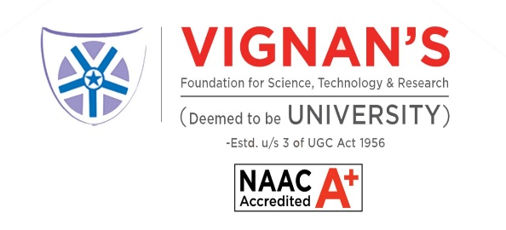

**INTER-DISCIPLINARY PROJECT**

**on**

**MOLECULAR DOCKING AND BINDING ANALYSIS OF SELECTED PHYTOCHEMICALS AGAINST TAP63**

*Submitted By*

**SNEHA SHRAVANI GURRAM**

**211FA14021**

*Submitted to*

**Dr. K.V.Chari**

Associate Professor

Department of Biotechnology

**Vignan`s Foundation for Science Technology and Research**

(Deemed to Be University), VADLAMUDI

GUNTUR – 522 213, AP, INDIA

May 2023





**CERTIFICATE**

This certificates that the project work entitled “**MOLECULAR DOCKING AND BINDING ANALYSIS OF SELECTED PHYTOCHEMICALS AGAINST TAP63”** that is being submitted by **SNEHA SHRAVANI GURRAM (211FA14021)** is a student of 3rd Bachelor of Technology in Bioinformatics 2nd semester has successfully completed Inter-Disciplinary Project (22BI304) during the academic year 2023-2024.

**Project Guide Head of the Department**

**External Examiner**

Place: Guntur

Date: 09 May 2024

**DECLARATION**

I hereby declare that work embodied in this thesis entitled **“MOLECULAR DOCKING AND BINDING ANALYSIS OF SELECTED PHYTOCHEMICALS AGAINST TAP63”** has been carried out by me under the supervision of by **Dr. K.V.Chari** is a student of 3rd Bachelor of Technology in Bioinformatics 2nd semester from the Department of Biotechnology, Vignan’s Foundation for Science, Technology and Research (Deemed to be University), Vadlamudi, Guntur. This project work was done by me.

**SNEHA SHRAVANI GURRAM**

**211FA14021**

**Acknowledgement**

I have taken efforts for the successful completion & outcome of Inter-Disciplinary Project. However, it would not have been possible without the kind support, a lot of guidance and assistance of many individuals and an organization. I’m extremely privileged to have got this for the completion of my project. I would like to extend my sincere thanks to all of them. We feel it our responsibility to thank **Dr. K.V.Chari** under whose valuableguidance that the project came out successfully**.** It is great pleasure for us to express our sincere thanks to Dr. K.V.Chari, Department of Biotechnology, VFSTR university for providing me an opportunity to do Inter-Disciplinary Project. We are extended our heartfelt gratitude to all our faculty members, who helped us in our academics thought course for completing this work.

**SNEHA SHRAVANI GURRAM**

**Contents**

Abstract

Objectives

Introduction

Materials and methods

Results

Discussions

References

**ABSTRACT**

Rheumatoid arthritis (RA) poses a significant challenge due to its autoimmune nature, characterized by severe joint pain and inflammation. Current treatment strategies often rely on drugs like Methotrexate(MTX), which although effective, can lead to adverse effects with prolonged usage. To address this, alternative therapies such as herbal compounds have gained attention.

In the present study, we aimed to explore the potential of herbal compounds to block the central molecules involved in pathophysiology of RA. Specifically, we investigated the binding affinity of four herbal compounds—Curcuma longa, Sophora flavescens, Marsdenia tenacissiame, and Acalypha wilkesiana—to the TAP63 protein, a key regulator implicated in RA pathogenesis. TAP63 structure was obtained from protein databank PUBMED. Chemical structure of herbal compounds were obtained from IMAPPAT . Using AUTODOCK VINA, molecular docking simulations were performed to predict the binding interactions between these compounds and TAP63. Molecular Dynamics (MD) simulations to elucidate the dynamic behavior of the Curcuma longa-TAP63 complex.

Among the tested compounds, Curcuma longa exhibited the highest binding affinity, with a docking score of -8.166. MD simulations enable the exploration of complex interactions at a molecular level, considering conformational changes, flexibility and intermolecular interactions over time. MD simulation results showed valuable insights into the stability and dynamics of the Curcuma longa-TAP63 complex, shedding light on the potential mechanisms underlying its therapeutic efficacy in RA. By understanding the molecular interactions between Curcuma longa and TAP63, this study contributes to the development of novel herbal-based treatments for RA offering promising alternatives to conventional therapies like MTX.

**OBJECTIVES**

* **Evaluating the potential of four herbal compounds (Curcuma longa, Sophora flavescens, Marsdenia tenacissiame, and Acalypha wilkesiana) as replacements for Methotrexate (MTX) in RA treatment.**

This objective highlights the project's core aim to find alternative therapies.

* **Investigate the binding affinity of these herbal compounds to the TAP63 protein.**

This objective focuses on the specific protein interaction being analyzed for potential therapeutic effects.

* **Identify the compound with the strongest binding affinity to TAP63.**

This narrows down the focus to finding the most promising candidate for further study.

* **Utilize Molecular Dynamics (MD) simulations to elucidate the dynamic behavior of the complex formed between the highest-affinity compound (Curcuma longa) and TAP63.**

This objective delves deeper into understanding the stability and interactions of the most compatible molecule.

**INTRODUCTION**

It all starts with the severe issue facing by many people in exception with their ages – Rheumatoid Arthritis. It is an Auto immune disease causing severely knee joint pains. Here going with the basic line auto immune disease is regulated by the **Treg cells**. They express CD4, CD25 and Foxp3 in CD4+ T cells. These Treg cells are the gate keepers of tolerance for preventing auto immune diseases.

FOXP3 is the central transcription factor that governs functional properties of Treg cells .Several studies identified that FOXP3 expression is positively correlated with Treg function. It is shown that TAP63 protein has negative effect on FOXP3 expression there by Treg function. Some reported that TAP63 attenuates FOXP3 expression by binding to CNS2 region of FOXP3 gene in Tregs.

Methotrexate (MTX) drug discovered which is a standard, first-line therapy for rheumatoid arthritis (RA). Methotrexate a major drug for RA that targets TAP63.Methotroxate shown to improve Treg function by blocking TAP63[REF].Further identified that Treg cells number and function was improved post Methotrexate treatment in RA patients via. Blocking TAP63.Additionally, reported that methotrexate shown positive correlation with FOXP3 and negative correlation with TAP63.

Even though methotrexate proven to be target drug for TAP63 several reports shown that long usage of methotrexate have adversive effects in RA patients.

In this contrast replacing the methotrexate with herbal compounds namely,

* Curcuma longa-IMPHY007574
* Acalypha wilkesiana-IMPHY001869
* Matrine-IMPHY004247
* Marsdenia tenacissiame-IMPHY010510

These herbal compounds are having good reactivity with replacing methotrexate drug. So,tested these molecule compatibility against tp63 protein by performing Autodock Vina and then then the dynamic behaviour of the molecules with MD Simulations.

**MATERIALS AND METHODOLOGY**

• **Materials**

* Herbal compound
* Protein structure data (obtained from PDB)
* Software:
  + AutoDock (for performing molecular interaction analysis)
  + PyMOL (for visualizing the molecular interaction)
  + Gromacs (for MD Simulation)

• **Methodology**

1. Retrieve the herbal compound.
2. Retrieve the protein structure data from PDB.
3. Prepare the compound for use with AutoDock software.
4. Prepare the protein structure data for use with AutoDock software.
5. Perform molecular interaction analysis using AutoDock.
6. Visualize the results using PyMOL.
7. Perform MD simulation using Gromacs software.

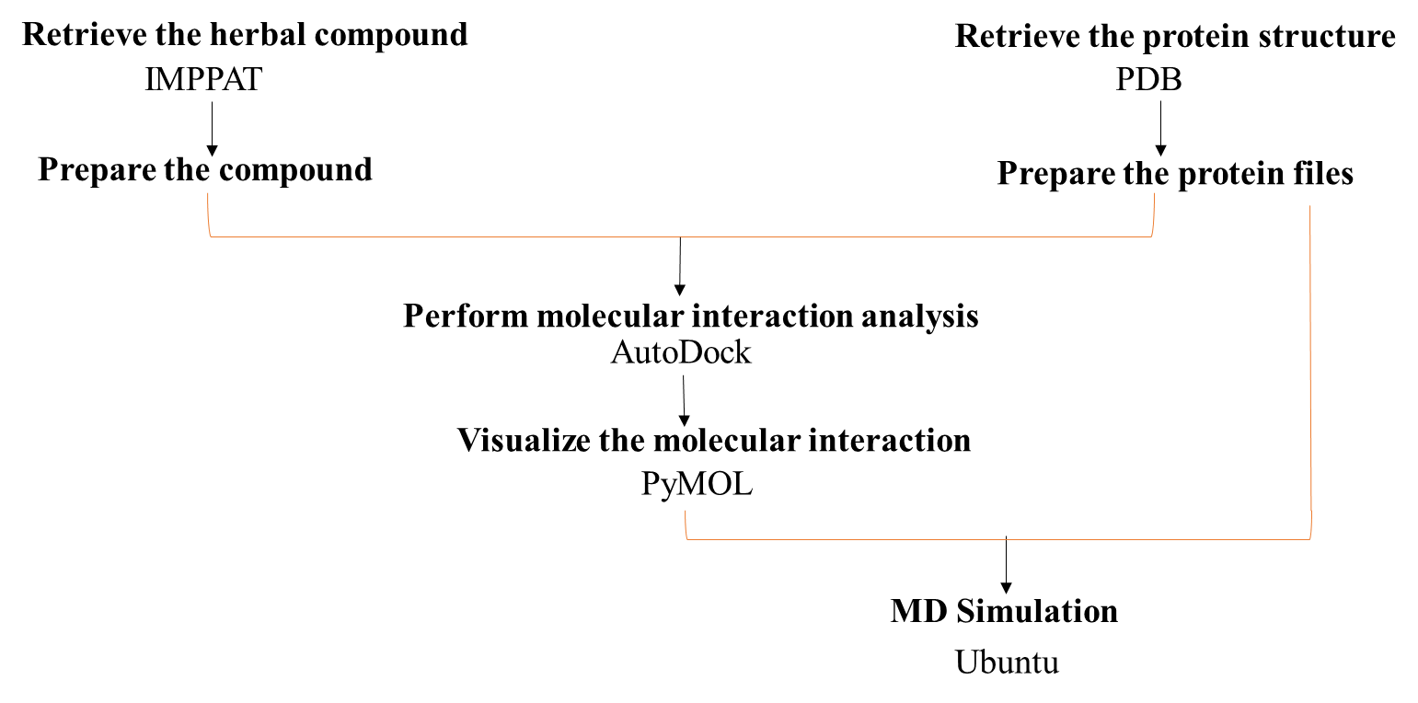

**RESULTS AND DISCUSSION**

**MOLECULAR DOCKING RESULTS**

Using PYMOL, we can visualize the docked molecules output,

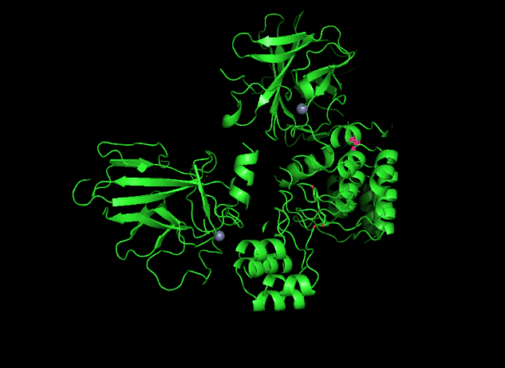 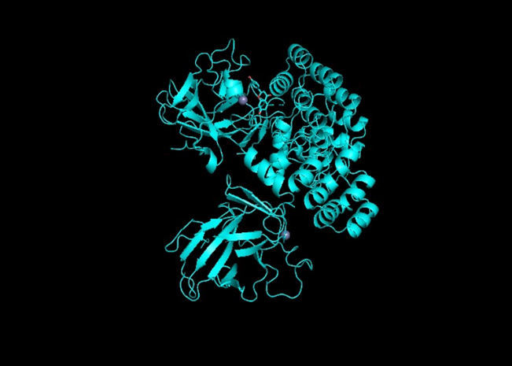

**Acalypha wilkesiana-IMPHY001869**

**Curcuma longa-IMPHY007574**

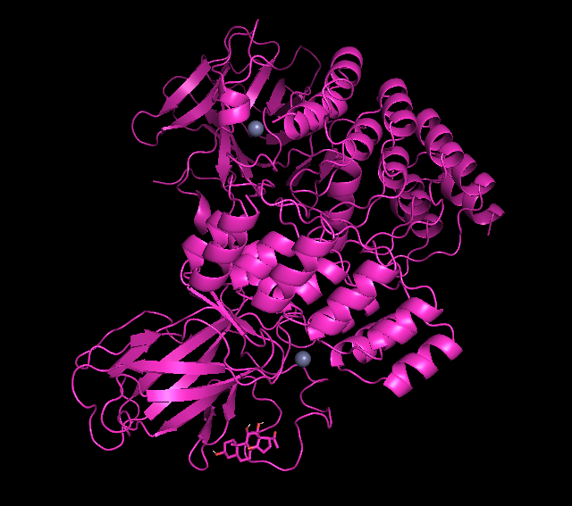 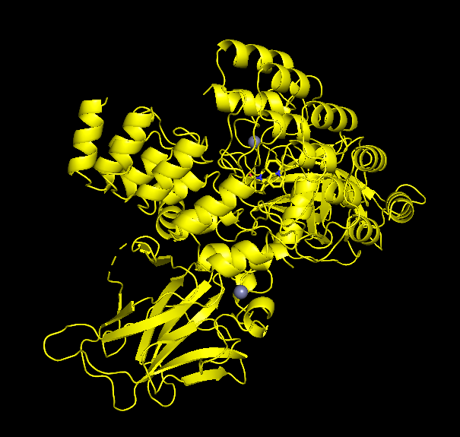

**Marsdenia tenacissiame-IMPHY010510**

**Matrine-IMPHY004247**

**Binding affinity :**

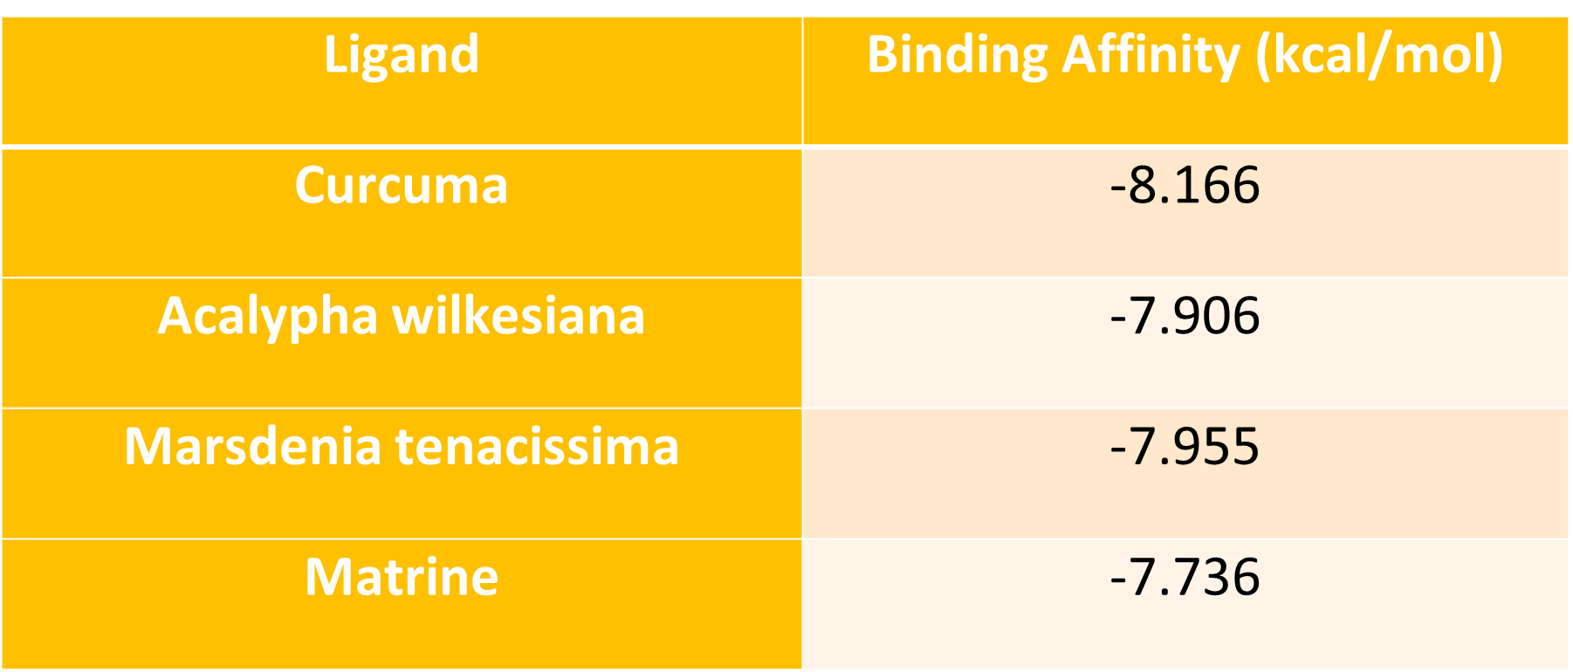

**Further CURCUMA LONGA MD SIMULATION RESULTS**

As we got best Curcuma longa , now we can proceed with MD Simulation for predicting the complex behaviour in a dynamic environment, including changes in conformation, flexibility, and interactions. The predicted results,

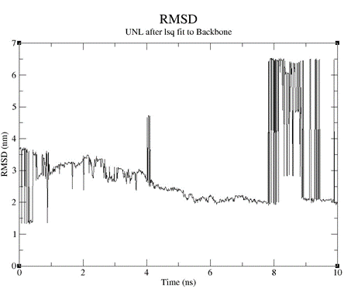 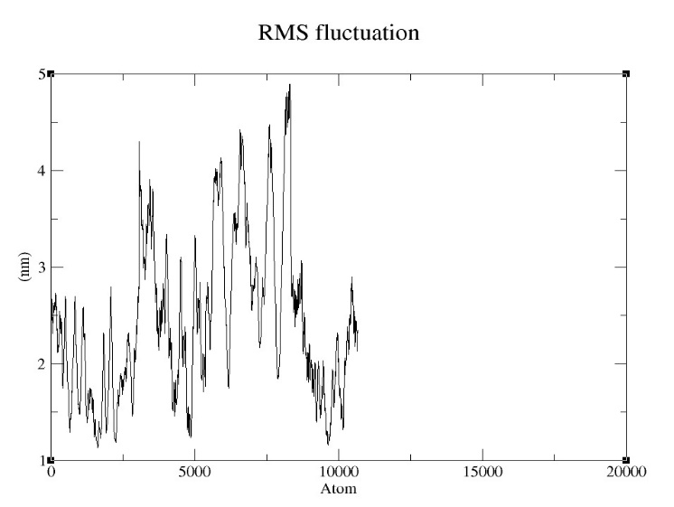

**CONCLUSION:**

In this study, we set out to explore alternative therapies for Rheumatoid Arthritis (RA) by evaluating the potential of herbal compounds to target the TAP63 protein, a key regulator implicated in RA pathogenesis. Among the tested compounds, Curcuma longa demonstrated the highest binding affinity to TAP63, with a docking score of -8.166 kcal/mol. This promising result underscores the potential of Curcuma longa as a candidate for further investigation as a therapeutic agent for RA.

Furthermore, molecular dynamics (MD) simulations were employed to delve deeper into the dynamic behavior and interaction profile of the Curcuma longa-TAP63 complex. MD simulations provide valuable insights into the stability, conformational changes, flexibility, and intermolecular interactions of the complex over time, offering a comprehensive understanding of its therapeutic efficacy.

By elucidating the molecular interactions between Curcuma longa and TAP63 through MD simulations, this study contributes to the development of novel herbal-based treatments for RA, offering promising alternatives to conventional therapies like Methotrexate (MTX). These findings highlight the importance of leveraging computational approaches such as molecular docking and MD simulations in drug discovery and development, paving the way for more effective and targeted therapies for RA and other autoimmune diseases.

In summary, the combination of molecular docking studies and MD simulations provides a powerful tool for understanding the mechanism of action and therapeutic potential of herbal compounds, ultimately advancing the quest for safer and more efficacious treatments for RA.

**REFERENCES**

* [FOXP3 modifies the phenotypic and functional properties of regulatory T cells | Nature Reviews Immunology](https://www.nature.com/articles/nri2061) - [Daniel J. Campbell](https://www.nature.com/articles/nri2061#auth-Daniel_J_-Campbell-Aff1) & [Steven F. Ziegler](https://www.nature.com/articles/nri2061#auth-Steven_F_-Ziegler-Aff1)
* [Regulatory T cells in Arthritis - ScienceDirect](https://www.sciencedirect.com/science/article/abs/pii/S1877117315001532?via%3Dihub)
* [IMPPAT | IMPPAT: Indian Medicinal Plants, Phytochemistry And Therapeutics (imsc.res.in)](https://cb.imsc.res.in/imppat/basicsearch/phytochemical)
* [CASTp 3.0: Computed Atlas of Surface Topography of proteins (uic.edu)](http://sts.bioe.uic.edu/castp/index.html?3igg)
* [PubMed for id: 1041817926 - Search Results - PubMed (nih.gov)](https://pubmed.ncbi.nlm.nih.gov/?from_uid=1041817926&linkname=protein_pubmed)
* [Overview of Methotrexate Toxicity: A Comprehensive Literature Review - PMC (nih.gov)](https://www.ncbi.nlm.nih.gov/pmc/articles/PMC9595261/)
* [JCI Insight - TAp63, a methotrexate target in CD4+ T cells, suppresses Foxp3 expression and exacerbates autoimmune arthritis](https://insight.jci.org/articles/view/164778/pdf)
* [TAp63, a methotrexate target in CD4+ T cells, suppresses Foxp3 expression and exacerbates autoimmune arthritis - PMC (nih.gov)](https://www.ncbi.nlm.nih.gov/pmc/articles/PMC10322677/#sd)
* [TAp63: A new protein drug target for rheumatoid arthritis (medicalxpress.com)](https://medicalxpress.com/news/2023-05-tap63-protein-drug-rheumatoid-arthritis.html#google_vignette)
* [Protein-Ligand Complex (mdtutorials.com)](http://www.mdtutorials.com/gmx/complex/index.html)
* [Improving Protein-Ligand Docking Results with High-Throughput Molecular Dynamics Simulations | Journal of Chemical Information and Modeling (acs.org)](https://pubs.acs.org/doi/abs/10.1021/acs.jcim.0c00057)